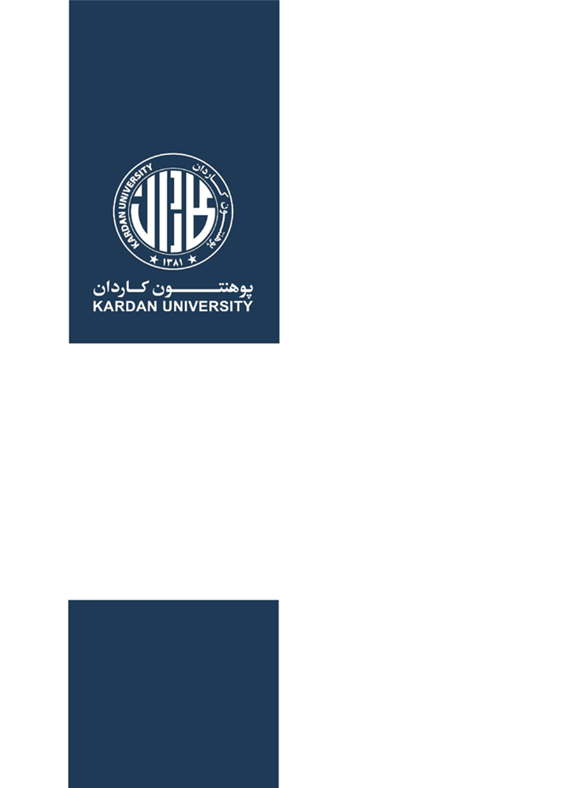

**September, 2017**

**3-Year Strategic Plan**

**Master’s in International Relations Program**

**Prepared by**

Mr. Fahim Sadat

Head of the Department

Master’s in International Relations

Signature:

**Checked by**

Dr. Ahmad Khalid Hatam

Dean

Faculty of Social Sciences

Signature:

**Approved by**

Ms. Meena Rahmani

Vice Chancellor (Academics)

Table of Contents

Our Vision 4

Our Mission 4

Our Values 4

Strategic Priorities, Outcomes And Key Objectives 5

1.1 Strategic Priority Area 1: Actively engage learners at all levels 5

Outcome 5

Objective 5

Baseline 5

Progress (2017 and 2018) 5

1.2 Strategic Priority Area 2: Further Develop the Exceptional Faculty 5

Outcome 5

Objective 5

Baseline 6

Progress (2017 & 2018) 6

1.3 Strategic Priority Area 3: Ensure Alignment of Institutional Structures and Functions 6

Outcome 6

Objective 6

Baseline **Error! Bookmark not defined.**

Progress (2018) 6

1.4 Strategic Priority Area 4: Enhance the Institution’s Image and Reputation 7

Outcome 7

Objective 7

Baseline 7

Progress (2018) 8

# Our Vision

To uphold a quality standard in imparting an international pedagogy and guiding practice within the interdisciplinary graduate study of International Relations.

# Our Mission

Transforming our graduates through International Relations knowledge offered as robust coursework, project work and critical engagement, into effective practitioners.

# Our Values

Striving to acquire and utilize knowledge of International Relations with **academic freedom**, **critical thinking**, **methodological and theoretical pluralism** and encouraging **disciplinary collaboration**.

* We value excellence in education facilitated through
* Active student-teacher engagement and academic achievement in a rigorous and challenging course of study that emphasizes the development of critical and analytical thinking and writing.
* Student exposure to a variety of theoretical and political perspectives for the purpose of enhancing critical and analytical thinking and writing skills.
* A comprehensive coverage of the disciplines and access to a wide variety of advanced level courses.
* Emphasis on empirical skills, extra- and co-curricular activities and civic education opportunities in domestic, regional and international level.
* Excellence and improvement in the faculty generated scholarship
* Service to enhance quality standardization of university and community cultures
* Student development as informed practitioners in a democratic society.

### 

# Strategic Priorities, Outcomes And Key Objectives

## **Strategic Priority Area 1: Actively engage learners at all levels**

### **Outcome**

Kardan School of Graduate Studies’ learning environment is active, challenging and transformational, supporting excellent academic program and co-curricular opportunities.

### **Objective**

The Department of International Relations focuses on transformation through practical work, instilling critical thinking skills and analysis with strong theoretical foundations for students.

### **Baseline**

Prospective students’ knowledge of the chosen major is determined by a comprehensive admission test conducted by the university. The prospective students’ responses in an interview are used to evaluate students’ interest and knowledge of the subject.

### **Progress (2017 and 2018)**

Students passed the entry test and the interview conducted by the Department.

## **Strategic Priority Area 2: Further Development of the Faculty**

### **Outcome**

The MIR Program at the Kardan School of Graduate Studies supports innovative teaching, learning, integrative scholarly and creative activities, and the use of modern technology in pursuing up-to-date research in respective fields of expertise contribution to the global scholarship.

### **2. Objective**

To invite and withhold diverse and balanced pool of qualified high achieving faculty members who can uphold the international standards of imparting International Relations education. Kardan University is equal opportunity employer open to faculty members from all regions, nationalities, genders and ethnicities.

### **Baseline**

Faculty’s education background assessment and university’s recruitment policies for faculty members and staff.

### **Progress (2017 & 2018)**

Faculty members holding PhD and Master’s degrees from India, U.S, U.K and other countries are recruited.

## **Strategic Priority Area 3: Ensure Alignment of Institutional Structures and Functions**

### **Outcome**

MIR Degree Program at Kardan University shall be aligned with the university’s institutional structures, procedures and standards set by Afghan Ministry of Higher Education (MoHE) while seeking standardization with internationally accepted academic protocols.

### **3. Objective**

### To establish and run a Department of International Relations under the university protocol, Ministry of Higher Education Policies and international academic standards.

Kardan University’s Quality Assurance and Accreditation Department (QAAD) that ensures compliance with MoHE’s requirements and pursues international standards in quality assurance.

### **Progress (**2018)

A Quality Assurance and Accreditation Committee (QAAD) has been established at the department level to ensure department functions in accordance with the university and MoHE’s requirements.

## **Strategic Priority Area 4: Enhance the Institution’s Image and Reputation**

### **Outcome**

Department of International Relations is to establish and sustain mutually beneficial relationships, partnerships, collaborations, and connections at the national and international level with academic and other institutions.

### 

### **4. Objective**

**Digitalization**

1. Ensure that faculty and students are well-versed with computer applications and online search and research
2. Assist the students and faculty members in understanding the basic functions of LMS and MIS
3. To sustain excellence in innovation and growth that leads to fostering positive image of the university not only in the Afghan community, but also at the regional and international level.

### **Baseline**

Department’s recognition at the national level and alumni’s professional achievements through scholarships and career developments.

## **Strategic Priority Area 4: Enhance the Institution’s Image and Reputation outside**

**5. Objective**

**Public Engagement**

1. Students should have opportunities of volunteering and working with organizations that work with people
2. Maintaining our commitment to student service.

### **Progress (2018)**

Memoranda of Understanding (MoUs) and Instruments of Collaboration (IoCs) signed and implemented with several government entities as well as national and international organizations to collaborate with Department of International Relations and Kardan University.

Guest speakers and experts were therefore invited to speak at the university to students, faculty and promote university’s programs and development. Students have been invited to pay visits to these government and non-governmental entities.

## **Outcome:**

An established department of MIR that reflects market needs and offers cutting edge academic program with potential to expand..

A batch of highly skilled and well trained future diplomats and foreign affairs experts would graduate in the coming months. (further development)